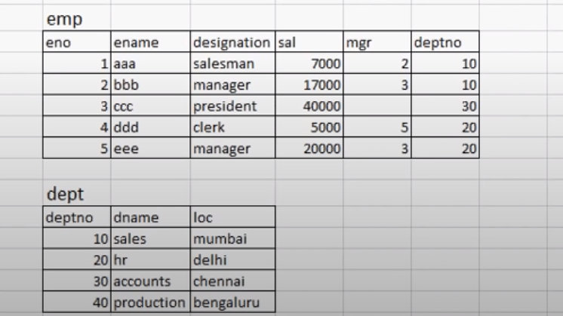
Create an Employee table and Department Table as above and Perform the Following Exercise using Subqueries.
- Amongst Manager who Gets Highest Salary?
- Get the Details of Clerk earning 5000?
- Which Designation has exactly 2 employees?
- Which Designation has the greatest number of Employees?
- Which Designation has the Least?
- What is the Second Highest Salary?
- Who gets the Second Highest Salary?

